Town Ants / Leafcutter Ants
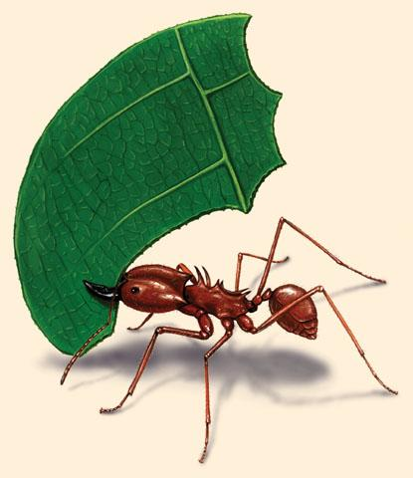
The Texas leaf cutting ant, Atta texana (Buckley),aka town ant, cut ant, parasol ant, fungus ant and night ant, destructive to landscape plants, gardens and crops. The name comes from their habit of cutting leaves; the ants do not eat the leaf fragments but take them into underground nests where they raise a fungus garden. As the fungus grows, it is eaten by the ants and fed to the larvae. Leaf cutting ants will attack pine trees but ordinarily they do little damage when other green plants are available. However, in winter when green plant material is scarce, seedling pines are frequently damaged in parts of East Texas; young pine seedlings often are destroyed within days unless ants are controlled before planting. Because leaf cutter ants only eat the fungus they cultivate, they do not respond well to most ant baits.
DESCRIPTION - Leaf cutting ants are rust to dark-brown and vary greatly in size. Worker ants range from 1/16 to 1/2 inch long. The queen is about 3/4 inch long. Leaf cutter workers can be distinguished from other ants by their three pairs of prominent spines on their back (thorax) and one pair of spines on the back of the head. Most larvae develop into sterile female worker ants; however, in the spring, some larvae develop into winged males and females. They are distinct from worker ants, being several times larger, often not recognized as the same species, and are dark, rusty brown with long, black wings.
LIFE HISTORY AND HABITS - Mating flights of leaf cutter ants take place on moonless nights during April, May and June. In areas of higher rainfall, swarms can occur at any time during the spring. The colony is marked by numerous crater-shaped mounds, 5 to 14 inches-high and up to 1 to 1.5 feet in diameter with a central hole. Above the nest cavity, several entrance holes will be marked by mounds and a buildup of soil. Below ground, several chambers may reach 15 to 20 feet deep and are interconnected by narrow tunnels. Vertical tunnels extend to mound openings, and lateral foraging tunnels may lead outward 500 feet. These lateral exits are commonly referred to as "feeder holes." The complex structure of cavities and tunnels allows ants to escape predators and provides an efficient air circulation system. The large complex nest structure makes control with insecticides difficult.
DAMAGE SYMPTOMS - Defoliation by leaf cutting ants can resemble damage produced by other leaf chewing insects. Trees defoliated by the leaf cutting ant usually are within sight of an ant nest and the ants may be seen carrying leaves. Foraging trails will be littered with pieces of leaf tissue that can be traced to a feeder hole. Considerable damage to a plant can occur in a few hours. Trees can be stripped in one night.
CONTROL - Control of leaf cutting ants is difficult. Although plants can be protected temporarily using powder or granular formulations of contact insecticides like acephate (Orthene®), carbaryl (Sevin®) or permethrin, these treatments must be reapplied frequently. Also, plant applications do not eliminate underground colonies. The large size and complexity of leaf cutter ant nests makes it difficult to obtain good control with dust, liquid or granular insecticides. Because these ants eat only the fungus they cultivate, they do not respond to most other ant baits such as those labeled for fire ants. The most widely available consumer products for leafcutter ant control include acephate dusts and insecticide granules labeled for general ant mound control. These products should be applied to all nest openings according to label directions. If possible, dusts should be blown into nest openings using a garden duster or squeeze bottle. It may be difficult to obtain complete control of large, well-established colonies using these products.
SAFETY FIRST - Before using any chemical, READ THE LABEL and follow all instructions and safety precautions. Avoid chemical contact with skin. Wash exposed areas with generous amounts of soap and water. Store chemicals away from human dwellings in locked cabinets and out of reach of children and pets.
Do you need to take the Private Applicator training class? The AgriLife office in Jasper is taking sign-ups. Call 409-384-3721 to put your name on the list for the next class, date to be announced.

