**Better Living for Texans**

**Newsletter for Polk County Families C:\Users\dsmith\AppData\Local\Microsoft\Windows\Temporary Internet Files\Content.IE5\LFF57I08\MC900022565[1].wmf**

***__________________________________________________________________________________April 2015_________***

**Springtime is here!**

In Texas, three out of four deaths are attributed to a chronic disease. However, studies show an intake of at least two and half cups of vegetables and fruits per day as part of a healthy eating pattern can reduce the risk of certain chronic diseases. Lifestyles are hectic; however, increasing fruit and vegetables can be easy. Here are a few tips for making fruits and vegetables the easy choice!

* **Choose a variety of colors -** The colors in fruit and vegetables are not just to make them look pretty. Fruit and vegetable colors are complex and those colors pack a healthy punch in reducing the risk of developing various chronic diseases. Be sure to vary the colors on your plate.
* **Choose to make half your plate fruits and vegetables** The rest of your plate should be one-quarter grains and one-quarter protein foods with low-fat dairy on the side. MyPlate is a guide to making a healthy meal yet not every meal will look like MyPlate. For example a sandwich may not fit in each portion of the plate; however, making a sandwich with whole grain bread, lean protein, a slice of low-fat cheese, and adding lots of vegetables with a side of fruit make a healthy plate
* **Choose to flavor your water** - Flavored drinks are in every grocery store. However, they can be full of added calories. You can make your own flavored water by freezing diced fruits or vegetables and adding them to your water. When you finish your water have the fruit or vegetable as a snack! It can be as easy as freezing slices of cucumber or whole raspberries and adding them to your water!
* **Choose fruit and vegetables to start the day-**Fruits can be an easy choice at breakfast food. However, mix in some vegetables too. Try adding spinach to your eggs, avocado to your toast, or tomatoes to a breakfast sandwich.

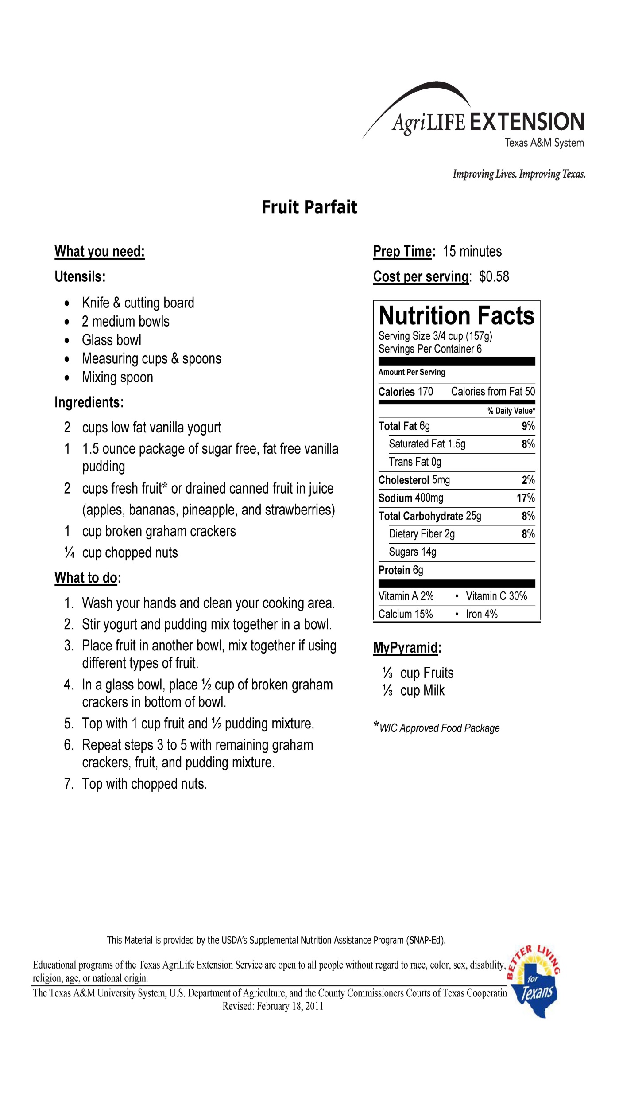



**What’s** in Season**?**

**April**

Corn Collard Greens

Strawberries Spinach

Limes Broccoli

Apricots Oranges

Green Beans Pineapple

Although most fresh fruits and vegetables are available at your local grocery store year-round, some are often less- expensive when bought in season. Keep in mind that all forms of fruits and vegetables are nutritious so frozen and canned forms are great too!

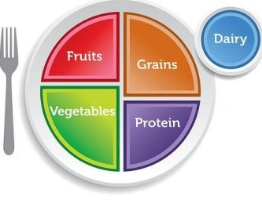

|  |
| --- |
| If you would like more information to help your family live a healthier life, call your local Family and Consumer Science County Extension Agent Cindy VanDevender at 409-384-3721 or you can reach us by email at c-vandevender@tamu.edu |