**Better Living for Texans**

**Newsletter for Nacogdoches County Families C:\Users\dsmith\AppData\Local\Microsoft\Windows\Temporary Internet Files\Content.IE5\LFF57I08\MC900022565[1].wmf**

***__________________________________________________________________________________August 2014_________***

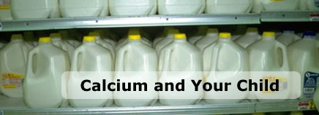

**What Calcium Does**

During childhood and adolescence, the body uses the mineral calcium to build strong bones — a process that's all but complete by the end of the teen years. Bone calcium begins to decrease in young adulthood and progressive loss of bone occurs as we age, particularly in women.

Teens, especially girls, whose diets don't provide the nutrients to build bones to their maximum potential are at greater risk of developing the bone disease osteoporosis, which increases the risk of [fractures](http://kidshealth.org/parent/general/aches/b_bone.html) from weakened bones.

Younger kids and babies who don't get enough calcium and vitamin D (which aids in calcium absorption) are at increased risk for rickets. Rickets is a bone-softening disease that causes severe bowing of the legs, poor growth, and sometimes muscle pain and weakness.

Calcium also plays an important part in making sure that muscles and nerves work properly, and in the release of hormones and enzymes. So if blood calcium levels are low, the body takes calcium from the bones to help these functions.

When kids get enough calcium and physical activity during childhood and the teen years, they can start out their adult lives with the strongest bones possible. For optimal bone health, the Institute of Medicine (IOM) recommends:

* 1 to 3 years old — 700 milligrams of calcium daily
* 4 to 8 years old — 1,000 milligrams of calcium daily
* 9 to 18 years old — 1,300 milligrams of calcium daily

Getting enough calcium is just part of the equation. Kids 1 to 18 years old also should get 600 IU of vitamin D daily. If you don't think your kids are getting the nutrients needed, talk to your doctor about changing their diet or using vitamin supplements.

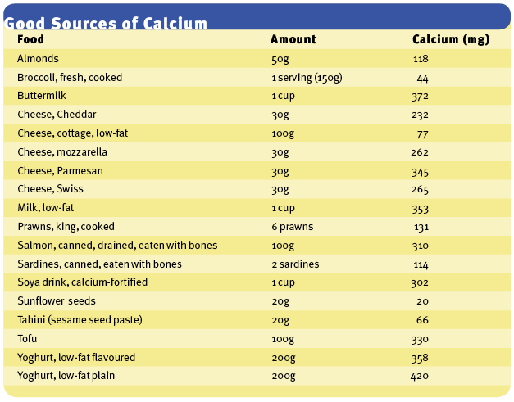

**Strawberry Smoothie**

Prep time: 5 minutes

C:\Users\CEO06\AppData\Local\Microsoft\Windows\Temporary Internet Files\Content.IE5\I5PCWQHM\MC900445722[1].wmf

Ingredients:

2 ice cubes

1 c. milk

1/3 c. cottage cheese

2/3 c. frozen strawberries

1 1/2 tsp. sugar

1 tsp. vanilla extract

Directions:

Pour all of the ingredients into a blender.

Put the lid on the blender and blend for 45 to 60 seconds until smooth.

Pour your smoothie into a glass and enjoy.

Serves: 1

Serving size: 1 large glass

Nutritional analysis (per serving):

289 calories

19 g protein

2 g fat

49 g carbohydrate

3 g fiber

7 mg cholesterol

430 mg sodium

369 mg calcium

0.8 mg iron

C:\Users\CEO06\AppData\Local\Microsoft\Windows\Temporary Internet Files\Content.IE5\0JY8FWFI\MC900440552[1].wmf

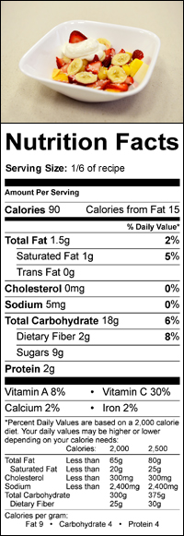

**Taste The Tropics**

**Prep time:** 15 minutes

**What you need:**

* 3 apricots, pitted and diced
* 3 bananas, peeled and sliced
* 6 large strawberries, trimmed and cut into quarters
* 6 tablespoons vanilla or plain Greek-style yogurt
* 4½ tablespoons shredded unsweetened coconut

**Equipment and supplies:**

* Knife for cutting fruit
* Bowls for serving

**What to do:**

1. In a medium bowl, stir together the apricots, bananas, and strawberries.
2. Scoop the fruit salad into small bowls and top each with 1 tablespoon yogurt.
3. Sprinkle the shredded coconut on top.

**How much does this recipe make?**

* 6 servings

|  |
| --- |
| If you would like more information to help your family live a healthier life, call your local Family and Consumer Science County Extension Agent Claudann M. Jones at 936-560-7711 or you can reach us by email at [cmjones@ag.tamu.edu](mailto:cmjones@ag.tamu.edu) |
|  |