**Better Living for Texans**

**Newsletter for Newton County Families C:\Users\dsmith\AppData\Local\Microsoft\Windows\Temporary Internet Files\Content.IE5\LFF57I08\MC900022565[1].wmf**

***________________________________________________________________________________September 2014___***

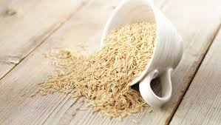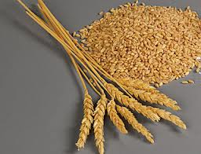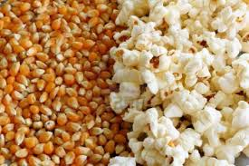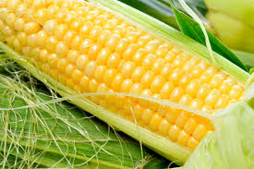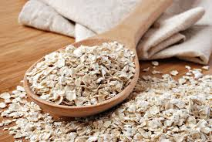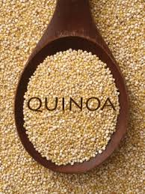

*Health experts advise everyone – men and women, young and old – that grains are a healthy necessity in every diet, and that it's important to eat at least half our grains as "****whole grains****." Whole grains include grains like wheat, corn, rice, oats, barley, quinoa, sorghum, spelt, rye – when these foods are eaten in their "whole" form. Whole grains even include popcorn!*

*The* [*medical evidence*](http://wholegrainscouncil.org/whole-grains-101/health-studies-on-whole-grains) *is clear that whole grains reduce risks of heart disease, stroke, cancer, diabetes and obesity. Few foods can offer such diverse benefits.*

***Easy Ways to Enjoy Whole Grains***

* *Substitute half the white flour with whole wheat flour in your regular recipes for cookies, muffins, quick breads and pancakes.*
* *Replace one third of the flour in a recipe with quick oats or old-fashioned oats.*
* *Add half a cup of cooked bulgur, wild rice, or barley to bread stuffing.*
* *Add half a cup of cooked wheat or rye berries, wild rice, brown rice, sorghum or barley to your favorite canned or home-made soup.*
* *Use whole corn meal for corn cakes, corn breads and corn muffins.*
* *Add three-quarters of a cup of uncooked oats for each pound of ground beef or turkey when you make meatballs, burgers or meatloaf.*
* *Stir a handful of rolled oats in your yogurt, for quick crunch with no cooking necessary.*

# Whole Grain Corn Muffins

*Bob's Red Mill Natural Foods*

*Tasty corn muffins are always crowd pleasers, and these muffins have everything you could want. Amazing corn taste, whole grain goodness, and muffins are a perfect on-the-go snack for busy days.*

## Ingredients *1 1/2 cups medium grind cornmeal   1 cup whole wheat pastry flour   1 Tbsp baking powder   2 Tbsp evaporated cane juice   1/2 tsp. sea salt   1 egg, lightly beaten   1 cup milk   1/4 cup vegetable oil*

## *Instructions*

*1. Preheat oven to 400°F.  Grease a standard or mini muffin pan and set aside.  
2. Mix together the cornmeal, whole wheat pastry flour, baking powder, sugar and salt.  Add the milk, egg and oil and blend until smooth, careful not to over mix.    
3. Spoon batter into the muffin tins about 3/4 full.  Bake for about 20 minutes for the standard size and 12 minutes for the mini muffins.  When done, tops of the muffins should spring back when tapped.  
  
Visit www.bobsredmill.com for even more fantastic whole grain recipes.*

*Nutrition Facts per serving: Calories - 160, Calories from Fat - 60, Total Fat - 7g, Saturated Fat - 1g, Cholesterol - 20mg, Sodium - 230mg, Total Carbohydrate - 22g, Dietary Fiber - 4g, Sugars - 3g, Protein - 3g.*

***makes:*** *12 standard muffins, or 24 mini muffins****serving size:*** *1 standard muffin*

*For more information on Whole Grains check out http://wholegrainscouncil.org*

***Cathy Pearson***

County Extension Agent – Family & Consumer Sciences

Newton County; Phone: 409-379-4831

Email: [cathy.pearson@ag.tamu.edu](mailto:cathy.pearson@ag.tamu.edu)

Website: <http://newton.agrilife.org/>

.